Project Design Phase
Problem - Solution Fit, Proposed Solution, Solution Architecture
Date | 31 October 2026
Roll Number | 323103282099
Project Name | Incident Lifecycle Automation in ServiceNow
Maximum Marks | Proposed Solution: 2 Marks, Solution Architecture: 4 Marks

Problem - Solution Fit
The Problem - Solution Fit canvas helped me check that what I was about to build actually matches how support teams work and what holds them back. I filled in all ten blocks with the Service Desk and Level 2 teams in mind.
Block | What I found
1. Customer Segment(s) | Service Desk agents, Level 2 network technicians, IT managers, and the employees who report IT issues
2. Jobs-to-be-done / Problems | Log, classify, route and resolve incidents within the SLA, and reuse fixes instead of solving the same issue again
3. Triggers | A user reports an outage. In my scenario, a Corporate VPN authentication failure
4. Emotions: Before / After | Before: rushed and unsure who owns the issue. After: in control, with a clear owner and a known fix
5. Available Solutions | Emails, phone calls and spreadsheets. They work, but there is no SLA timer and no link to changes or knowledge
6. Customer Constraints | Little time per ticket, several teams involved, and fixed SLA targets
7. Behaviour | Agents dig through old tickets and ask colleagues; technicians sometimes fix servers without logging a change
8. Channels of Behaviour | Online: the workspace and knowledge base. Offline: phone calls to the Service Desk
9. Problem Root Cause | There is no standard lifecycle tying incident, knowledge, change and SLA data together
10. Your Solution | A standard incident lifecycle in ServiceNow with Agent Assist knowledge, escalation to Level 2, an emergency change, child incidents, knowledge creation and SLA tracking

Proposed Solution
S.No. | Parameter | Description
1 | Problem Statement (Problem to be solved) | Incidents are handled inconsistently, escalated by hand and resolved without reusing knowledge, so SLAs get missed
2 | Idea / Solution description | Set up the full incident lifecycle in Service Operations Workspace: classification with service, offering and CI; Agent Assist; reassignment to Level 2; an emergency change; child incidents; a knowledge article from the resolution; and SLA tracking throughout
3 | Novelty / Uniqueness | One incident record ties together knowledge, change, child incidents and SLAs, so anyone can read the whole story in its Activity stream
4 | Social Impact / Customer Satisfaction | Users get faster and more consistent fixes, and agents spend less time searching and re-typing
5 | Business Model (Revenue Model) | Lower cost per ticket and fewer SLA breaches, using the ServiceNow licence the organization already has, with no custom code to maintain
6 | Scalability of the Solution | New services, groups, SLAs and knowledge bases are added as configuration, so the same flow works for any IT service, not just VPN

Solution Architecture
Solution architecture is where the business problem meets the technology. For me the main goals were to pick the right platform features, show how the pieces connect, and make it clear who does what at each stage.
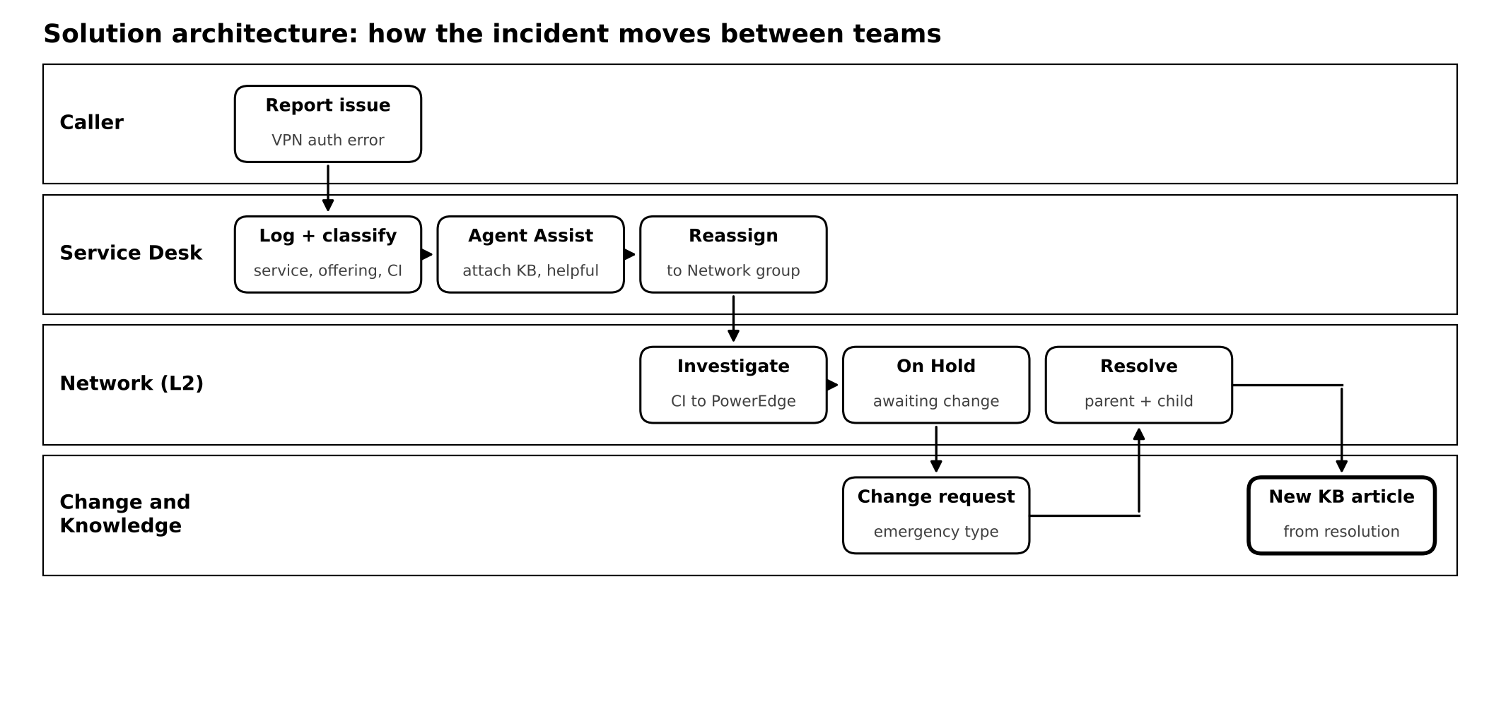
Figure 1: How the incident moves between teams
Reading the diagram from left to right:
- Caller: Michael Hoefer reports that the VPN gives an authentication error.
- Service Desk: Beth Anglin logs and classifies the incident (Network / VPN, Remote Access, Corporate VPN, CI), attaches a knowledge article through Agent Assist, and reassigns it to the Network group.
- Network (Level 2): David Loo picks it up, updates the CI to the PowerEdge server, and puts the incident On Hold while the change is pending.
- Change and Knowledge: an emergency change is raised for the restart. Once it is done, the incident and its child are resolved, and a new knowledge article is created from the resolution.
Underneath all of this, the SLA engine keeps timing the incident and pauses while it waits on the change.

